**Project Report on Data Analysis of Customer Retention in Ecommerce Sector**

1



**NAME OF THE PROJECT**

**PROJECT REPORT ON DATA ANALYSIS OF CUSTOMER RETENTION IN ECOMMERCE SECTOR**

**Submitted by:**

**MRS. NUPRIYA SAXENA**

**FLIPROBO SME:**

**MS. KHUSHBOO GARG**

1. **Project Report on Data Analysis of Customer Retention in Ecommerce Sector**

## ACKNOWLEDGMENT

I would like to express my special gratitude to “Flip Robo” team, who has given me this opportunity to deal with a beautiful dataset and it has helped me to improve my analyzation skills. And I want to express my huge gratitude to Ms. Khushboo Garg (SME Flip Robo), she is the person who has helped me to get out of all the difficulties I faced while doing the project.

A huge thanks to “Data trained” who are the reason behind my Internship at Fliprobo. Last but not least my parents who have been my backbone in every step of my life.

1. **Project Report on Data Analysis of Customer Retention in Ecommerce Sector**

# Chap 1. Introduction

## Business Problem Framing

Customer satisfaction has emerged as one of the most important factors that guarantee the success of online store; it has been posited as a key stimulant of purchase or repurchase intentions and customer loyalty. A comprehensive review of the literature, theories and models have been carried out to propose the models for customer activation and customer retention. Five major factors that contributed to the success of an e- commerce store have been identified as: service quality, system quality, information quality, trust and net benefit.

Customer retention strategies enable you to both provide and extract more value from your existing customer base. You want to ensure the customers you worked so hard to acquire stay with you, have a great customer experience, and continue to get value from your products. Therefore, knowing how to maximize the repurchase intention of Indians online consumers’ is vital for an online retailer in India to achieve its business goals. This may further lead to develop a general reference model for successful online retail business. Success of an online retail website depends on its system quality and how much consumer motivator values are derived through shopping from it.

The research furthermore investigated the factors that influence the online customers repeat purchase intention. The combination of both utilitarian value and hedonistic values are needed to affect the repeat purchase intention (loyalty) positively. The data is collected from the Indian online shoppers. Results indicate the e-retail success factors, which are very much critical for customer satisfaction.

## Conceptual Background of the Domain Problem

A successful business strategy today is not only developing cost- effective and highly targeted ways to reach out the new customers, it is more about keeping the existing customers engaged in the company. It has been acknowledged that bringing in new customers is expensive. Investment in the acquisition of new customers is six times higher than investing in existing customers. Increased performance in customer

1. **Project Report on Data Analysis of Customer Retention in Ecommerce Sector**

retention practices, on the other hand, has been found to create five times more impact than a similar amount of discount or cost of the capital, leading into the more profitable customer relationship.

* Studies have suggested that past online shopping experience, perceived usefulness, and customer satisfaction are factors capable of influencing a customer’s repurchase intention.
* Website quality (e-store) and the usability of the e-store have also been proposed as being very vital for e-retail success by studies.
* The customer retention model illustrates that for a customer to become loyal to an online retail brand, there must be satisfaction, which arises when the e-tailer possesses a quality system backed- up by the proper mix of values.

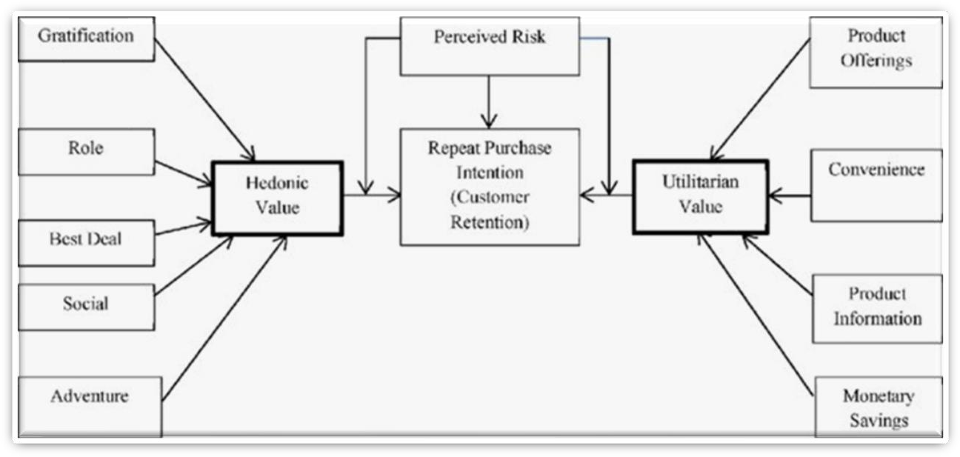

The situation in the market has changed, and the competition has become tougher. Customers have the luxury to choose between many providers. The increasing number of actors in the market has caused a rise in the significance and relevance of customer retention and the planning of a customer retention process is essential in order to achieve the desired level of outcome which is determined in the modern management

1. **Project Report on Data Analysis of Customer Retention in Ecommerce Sector**

literature. It focuses on the experience of purchasing the preferred product, instead of the product itself.

## Motivation for the Problem Undertaken

The project was the first provided to me by Flip Robo Technologies as a part of the internship programme. The exposure to real world data and the opportunity to deploy my skillset in solving a real time problem has been the primary motivation.

Our main objective of doing this project is to analyze whether the users are shopping products from e-commerce websites. How did they give feedbacks to these websites on the basis of several positive and negative factors and also the details of the users on basis of factors like age, gender, city etc.

1. **Project Report on Data Analysis of Customer Retention in Ecommerce Sector**

# Chap 2 Analytical Problem Framing

## Data Sources and their formats

The data is collected from the Indian online shoppers. Results indicate the e-retail success factors, which are very much critical for customer satisfaction. There are two sheets (one is detailed) and second is encoded in the excel file.

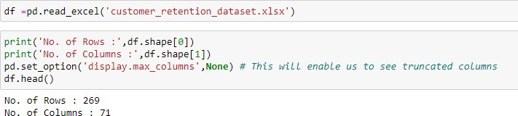

Dataset contain 71 columns with 269 rows. Out of which 1 feature with int datatypes and rest are with object datatypes.

## Data Pre-processing

Before pre-processing data, integrity of data is check for missing values,

possible duplicates, to check if any whitespaces or (‘- ‘) is present or not.

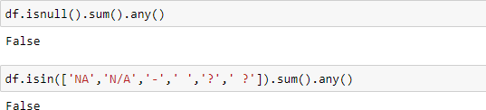

Data Pre-processing perform on data:

* There were few duplicate values in customer reviews. For example, Dis-agree and Diasgree. So made single value as both have the same meaning.
* Unnecessary spacing in columns name is removed.

1. **Project Report on Data Analysis of Customer Retention in Ecommerce Sector**

## 3. Hardware & Software Requirements with Tool Used

Hardware Used -

* 1. Processor — Intel i3 processor with 2.4GHZ
  2. RAM — 4 GB
  3. GPU — 2GB AMD Radeon Graphics card Software utilised -

1.Anaconda – Jupyter Notebook Libraries Used –

Different libraries are used while building ML model and Visualisation of data.



1. **Project Report on Data Analysis of Customer Retention in Ecommerce Sector**

# Chap. 3 Models Development & Evaluation

## IDENTIFICATION OF POSSIBLE PROBLEM- SOLVING APPROACHES (METHODS)

There are lot of features in dataset. Our objective is to find key conclusions & finding related to data using analysis. The features are categorised into few sections so we can perform analysis data section wise focus on particular area. They are enlisted as below:

* + - General feature describing Population and online shopping feature
    - Feature describing technological aspects related to internet services & device
    - Purchase Decision & Payment related features
    - Website Usability & performance related feature
    - Online shopping store customer service requirement related features
    - Feature related to Customer online shopping experiences
    - Online Shopping Platform related question response by Customer

## VISUALIZATIONS

### General feature describing Population and online shopping

Let’s start EDA with Gender distribution of respondent.

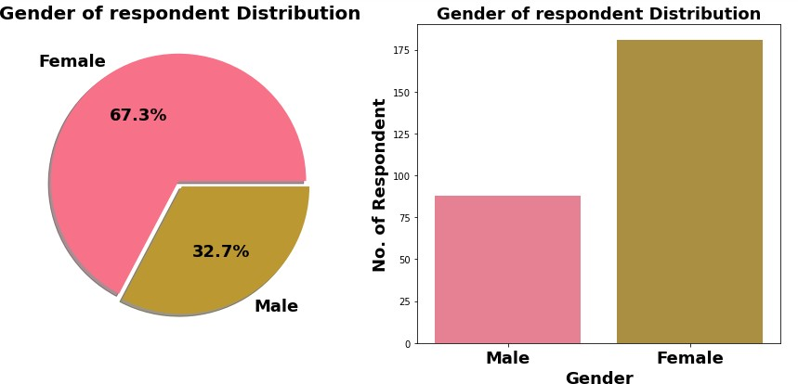

1. **Project Report on Data Analysis of Customer Retention in Ecommerce Sector**

The Majority of Respondent are Female (67.3%) & rest are Male respondent. *This also shows that women are more shopping oriented than men.*

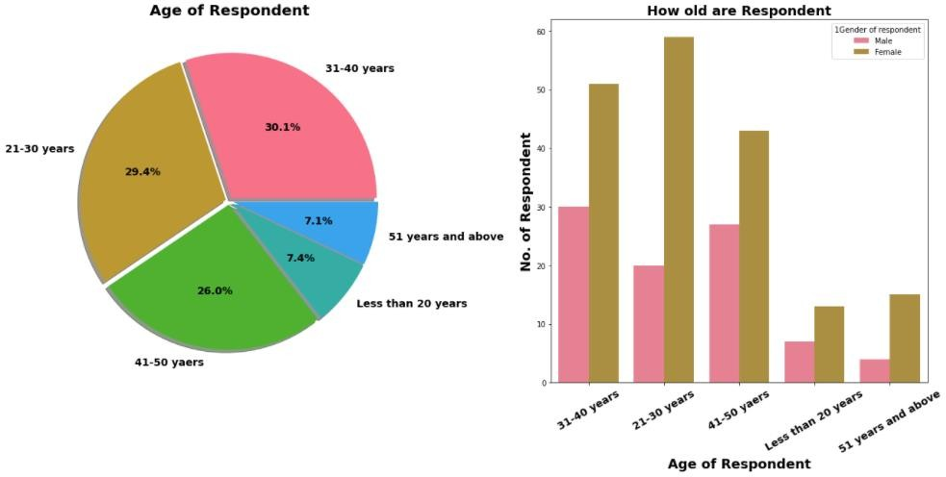

Observation:

* Majority of female customers are between age group of 21-40 years.
* Within Male Customers Tendency of online shopping seen among age group of 31-50 years.
* For both gender tendency of shopping is less for age greater than 51 years old. This may be due to decrease in materialistic tendency with age or possible Less TECH-SAVY Generation.

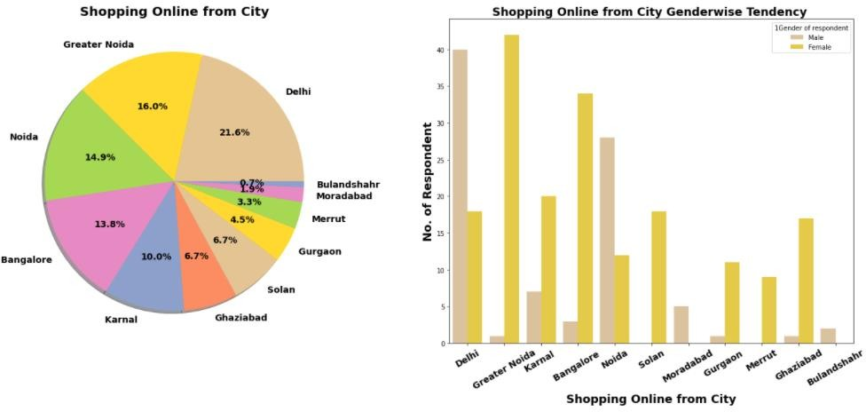

1. **Project Report on Data Analysis of Customer Retention in Ecommerce Sector**

Observation:

* Most Online Shopping Customer belong to Metro Cities. and most of them are Male customer. *We can conclude that in Metro city like Delhi, Male have more tendency of online shopping. shopping platform can target this population in marketing.*
* In Tier 2 & 3 Cities Majority of online shopping customers are Females. *We can run female product related campaign for this target customer population in these cities.*

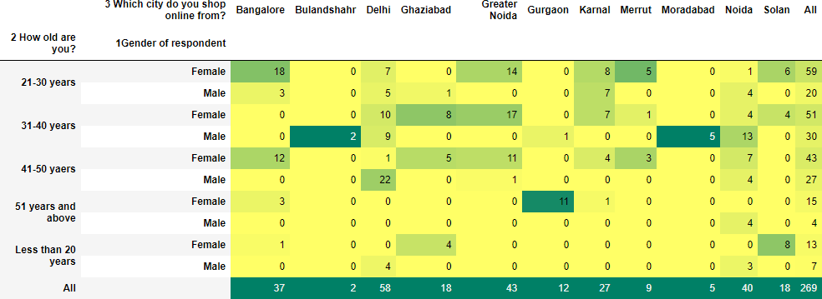

Observation:

We get interesting observation here in crosstab, as customer get older, they have less tendency for shopping *in turn they have less tendency to spend money.*

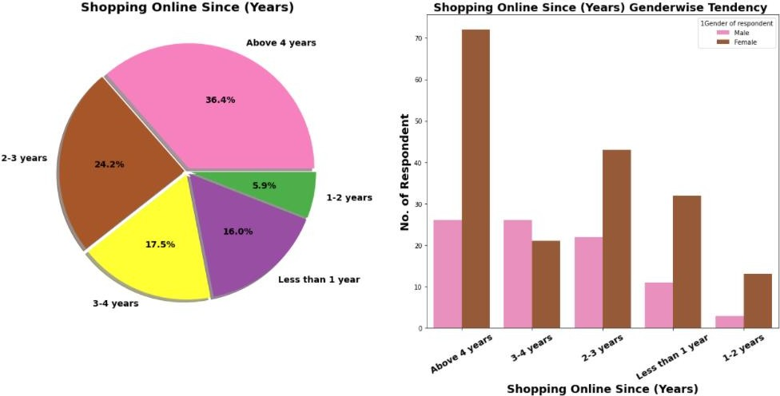

1. **Project Report on Data Analysis of Customer Retention in Ecommerce Sector**

Observation:

* 36.4% Respondent shopping online since 4 Yrs.
* Most of female shopping since 4 Yrs.

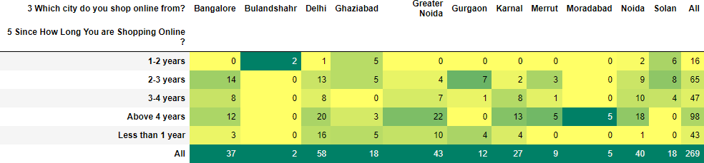

Observation:

* Online shopping is less popular in tier 3 cities like *Bulandshahar, Moradabad, Meerut.*

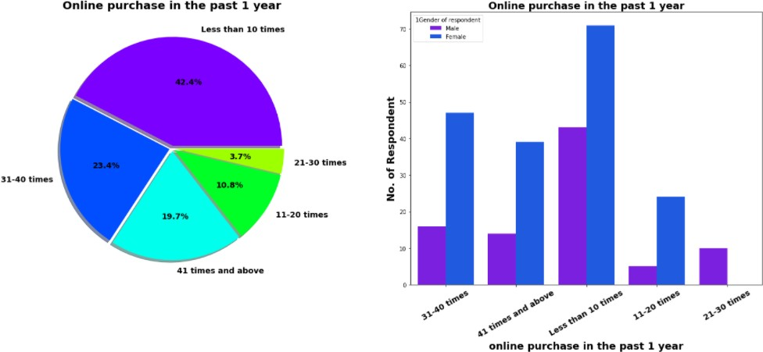

Observation:

* 42.4% Customers in last 1 year made online purchase less than 10 times.
* *Around 19.7% customers have made online shopping for 41 times & more in last 1 year*. Out which Majority are females.
* Another interesting observation no female had made shopping in range of 21-30 times.

1. **Project Report on Data Analysis of Customer Retention in Ecommerce Sector**

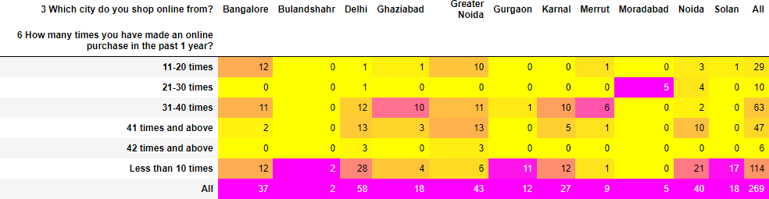

Observation:

* We can see that most of customer making purchase *for 41 times & more comes from city Delhi, Greater Noida, Noida.*

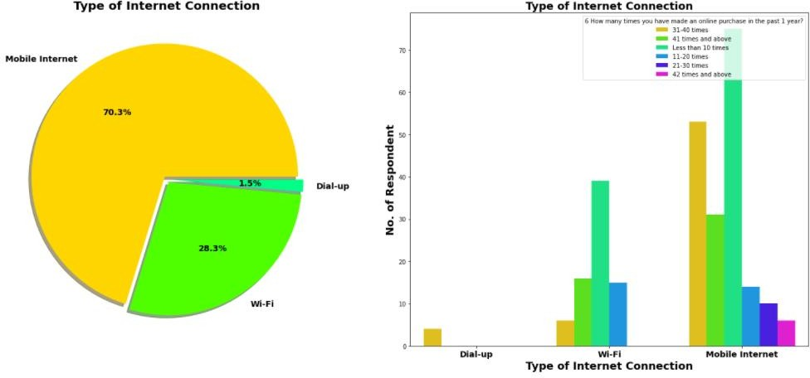

Observation:

* 70.3% Customers are mobile internet user followed by Wi-Fi User.

#### We can see that all customers who made online shopping for 41 times & more are using Mobile internet.

* Only 4 users are using Dial up Connection and all of them made online shopping for less than 10 times.

### Exploring feature describing technological aspects related to internet services & device

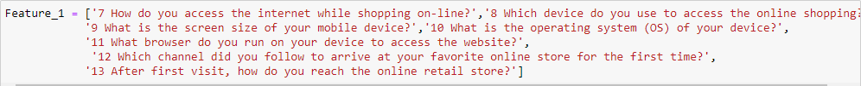

1. **Project Report on Data Analysis of Customer Retention in Ecommerce Sector**

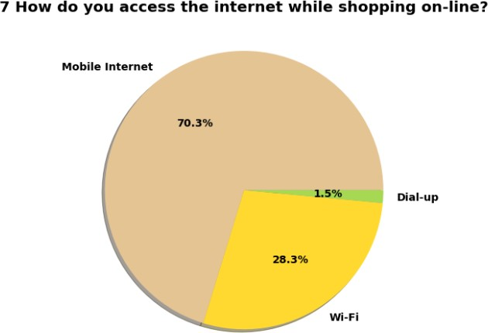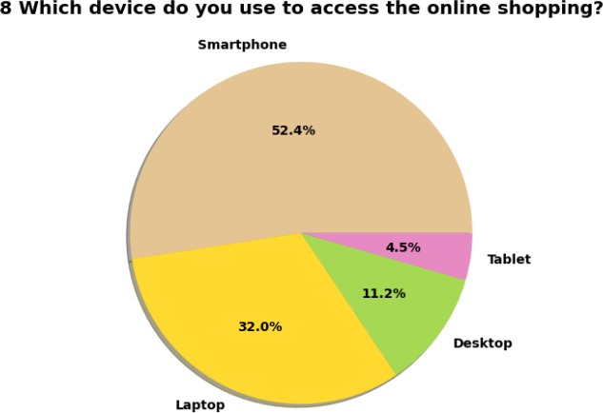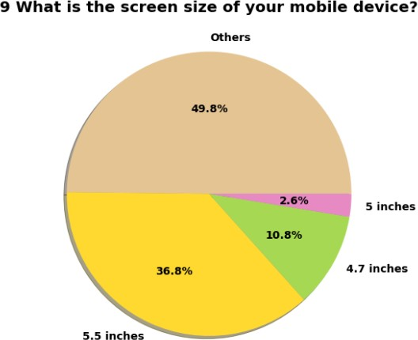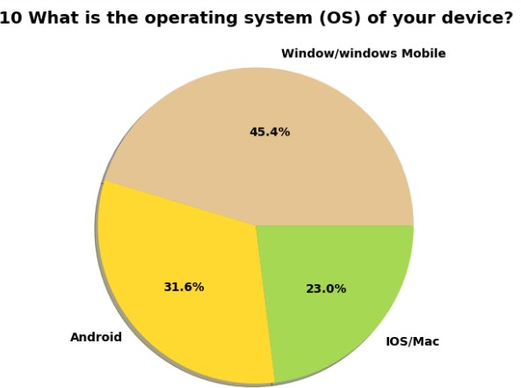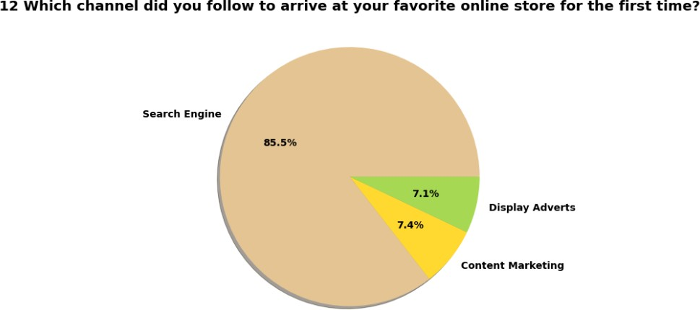

1. **Project Report on Data Analysis of Customer Retention in Ecommerce Sector**

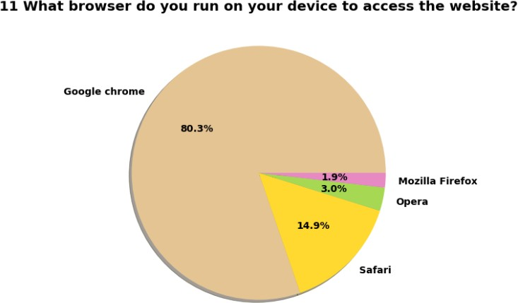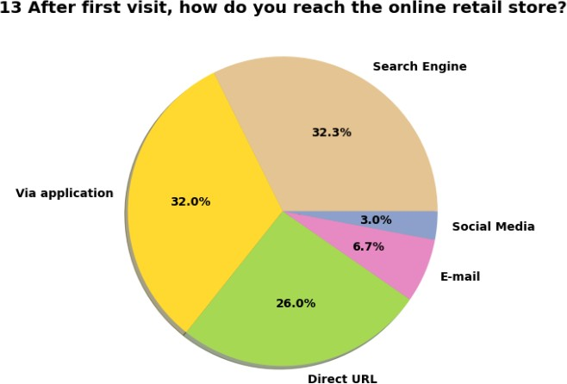

Observation:

* 70.3% Customer uses mobile internet for shopping.
* 52.4% Uses Smartphone followed by Laptop for online shopping. *Company can make device-oriented marketing strategy for different customers as per use of device.*
* Not all user uses smartphone for so we do not have screen size details of other user. Out of 52.4% Mobile users’ majority have 5.5- inch mobile display screen.

1. **Project Report on Data Analysis of Customer Retention in Ecommerce Sector**

* 45.4% customer have Windows operating system on their smartphone & laptop. *Followed by it around 31.6% customer uses Android as OS which can come from both smartphone & Tablet.*
* We can say that in terms of *browser google chrome dominate market.*
* We can see 85.5 % of Customer arrived on shopping platform through search engine. *Ads & Marketing campaign are not bringing much lead. Most of customer who made online purchase because they want to buy product or due to discount on online shopping*.
* After 1st Purchase 32% customer visit online store through mobile application and 32.3% by search engine.

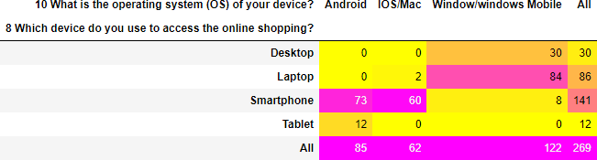

Observation:

#### No Tablet with IOS operating system.

* We already know 45.4% Customer uses Windows OS and *here we can see that almost all them come from desktop & laptop user.*
* Surprising only 2 Customer with Apple laptop and no customer with Apple desktop.
* 73 customers using android and 60 customers using Apple iPhone.

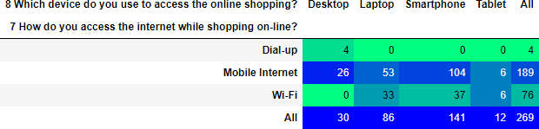

1. **Project Report on Data Analysis of Customer Retention in Ecommerce Sector**

Observation:

* No desktop with Wi-Fi Connectivity. All 30 desktop users are using mobile internet or dialup connection.
* Out of 141 Smartphone users 104 using mobile internet while rest using Wi-Fi.

#### We know that in first visit 85% Customer (230 Customer out of 269) came through search engine, here we are trying to figure after 1st visit how many of them reach by others channels like apps or email marketing.

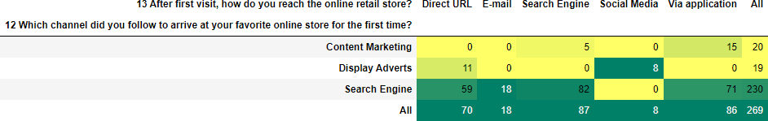

Observation:

* For 2ed & afterward visit 71 customer arrived online store via application, followed by 59 via Direct URL & 18 Customer Via Promotional Email Marketing.
* Display adverts have very poor performance in landing customer on online store. Similar with Social Media marketing. For 2ed Purchase no one landed through display adverts on search engine.

***It is strong recommendation to companies that Do not spend more money over social media marketing & Display Adverts in their Digital Marketing campaign instead of that focus on Search engine Optimization & Email Marketing which will likely to be more effective to earlier.***

### Exploring Purchase Decision & Payment related features



In this section we have categories feature related to purchase decision and payment method. Focus in this section is to gain understanding about

1. **Project Report on Data Analysis of Customer Retention in Ecommerce Sector**

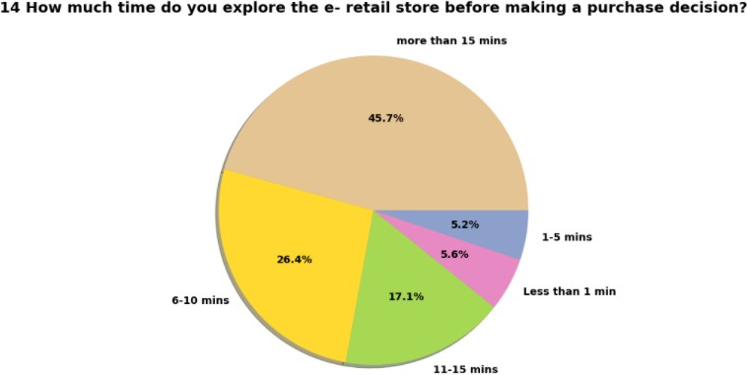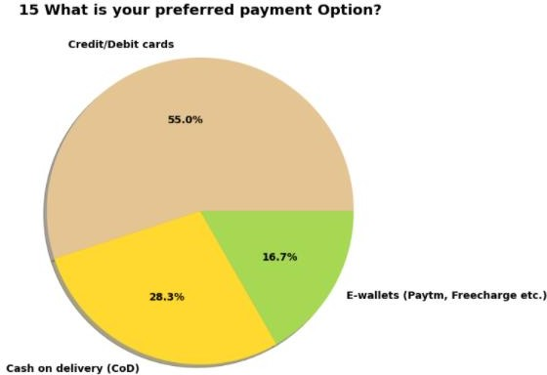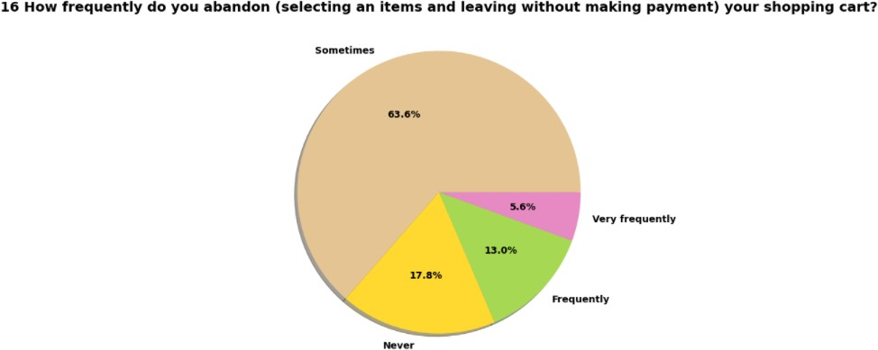

1. **Project Report on Data Analysis of Customer Retention in Ecommerce Sector**

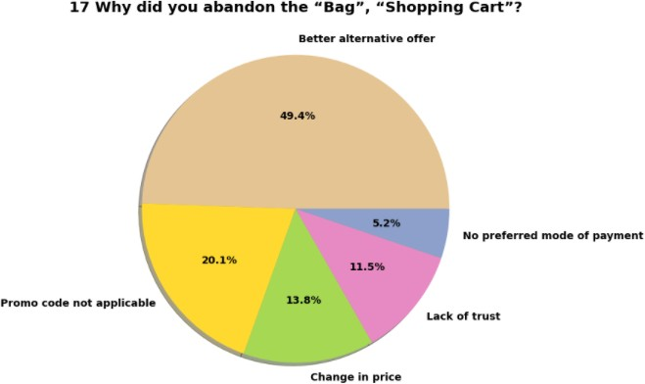

Observation:

* 45.7% of Customer spend more than 15 mins before making Purchase decision. Followed by the 17.1% customers with 11-15 mins before making purchase decision.
* *We can see that 5.6% of customers purchase product less than 1 min.* It will be interesting to find how many these customers made purchase in past 1 year.
* 55% of customer paid using credit/debit cards while 28.3% customers still prefer cash on delivery.
* We can see that *63.6% of customer add product in cart but later leave without making payment*. Surprising there is category of 17.8% customer who never abandon product without making payment.
* In next pie chart depict reason why customer change buying decision. *Around 50% customers abandon cart due to better alternative offer which is obvious reason*. Another most common reason to abandon purchase decision is promo code not applicable on particular product. Followed by next most common reason is change in price.

1. **Project Report on Data Analysis of Customer Retention in Ecommerce Sector**

* If we add reason mention in previous point, *we can conclude that 84% customer abandon cart due to cost & discount trade-off.*

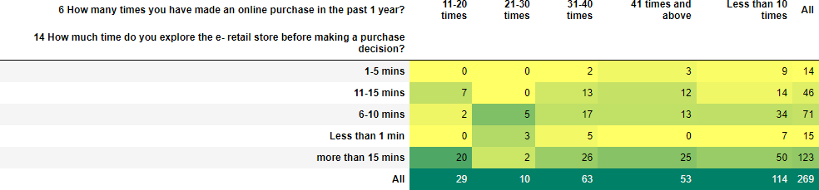

Observation:

* Here comes interesting observation about Customer who are spending more than 15 mins before making any purchase decision, out 45.7% these customers around 25 customer done online shopping more than 41 times in past year.
* 15 Customer purchase shopping within less than 1 min, Majority of them ,7 customer made shopping less than 10 times in past year.

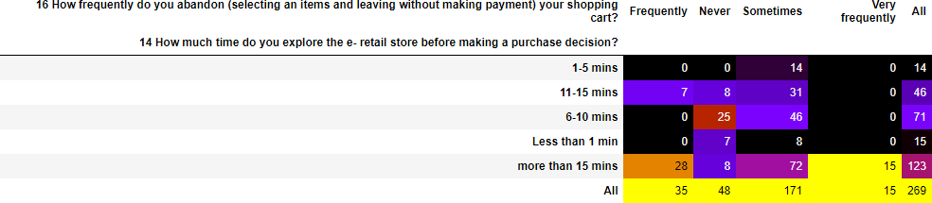

Observation:

* 171 Customer out of total 269 customer Sometimes abandon shopping cart.
* Customer spend more than 15 mins (Count=123 Customer) on online shopping store before making purchase decision have *More Tendency to Abandon*
* Customer who spends less than 5 mins before making purchase decision have seen with very less tendency to abandon cart, more specifically they never leave cart or rare abandon cart.

1. **Project Report on Data Analysis of Customer Retention in Ecommerce Sector**

### Exploration Of Website Usability & Performance Related Feature

In this section we are going to analyse feature descripting website usability & performance. Following features, we have analysed in this section:

* 1. 18 The content on the website must be easy to read and understand
  2. 19 Information on similar product to the one highlighted is important for product comparison
  3. 20 Complete information on listed seller and product being offered is important for purchase decision.
  4. 21 All relevant information on listed products must be stated clearly.
  5. 22 Ease of navigation in website
  6. 23 Loading and processing speed
  7. 24 User friendly Interface of the website
  8. 25 Convenient Payment methods
  9. 26 Trust that the online retail store will fulfil its part of the transaction at the stipulated time

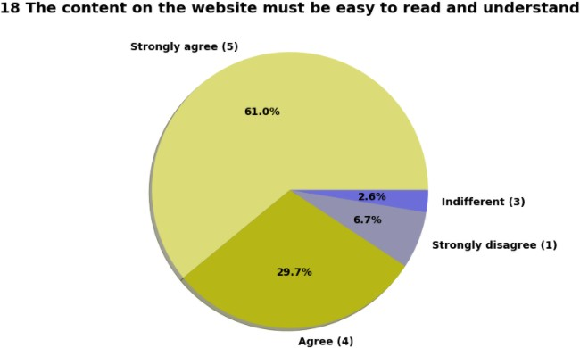

1. **Project Report on Data Analysis of Customer Retention in Ecommerce Sector**

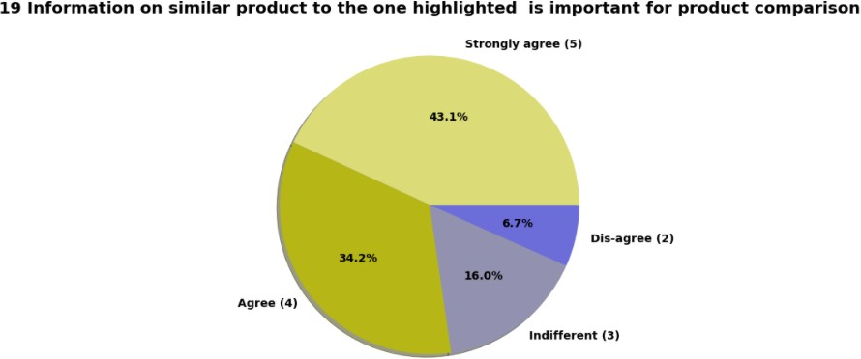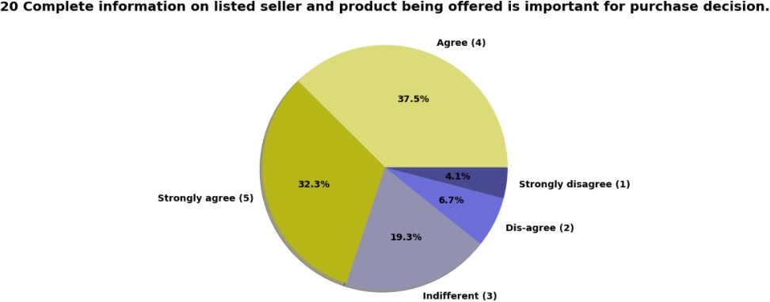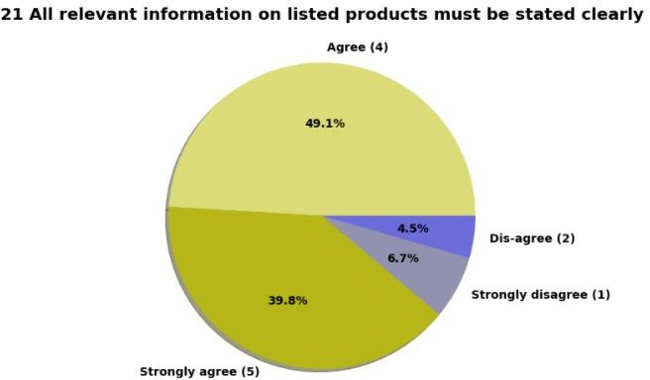

1. **Project Report on Data Analysis of Customer Retention in Ecommerce Sector**

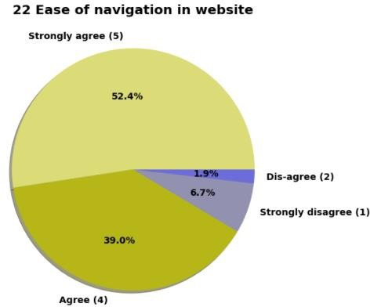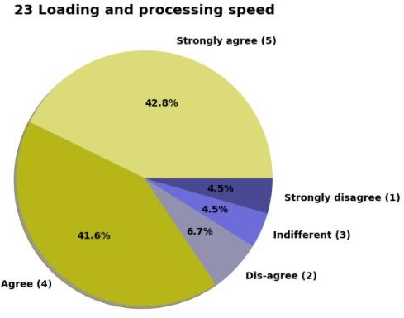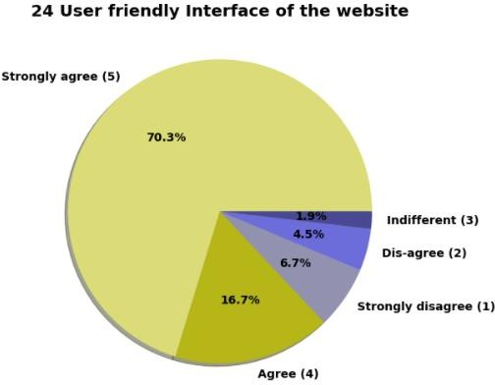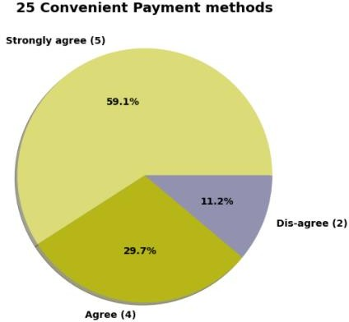

Observation:

* 61 % customer strongly agree and 29.7% customer agree that content on website must be easy to read and understand.
* 43.1% customer strongly agree and 34.2% customer agree that information on similar product to highlighted on website for product comparison.
* More than 60% of customer agree or strongly agree that complete information on listed seller and product being offered is important for purchase decision.
* More than 90% of customer agree or strongly agree that all relevant information on listed products must be stated clearly.
* Around 93% of customer agree or strongly agree that website should be easy for navigation.

1. **Project Report on Data Analysis of Customer Retention in Ecommerce Sector**

* 42.8 % customer strongly agree and 41.6 % customer agree over high loading & processing speed.
* 70.3 % customer strongly agree and 16.7 % customer agree that website should be user friendly.

### Exploration Of Online Shopping Store Customer Service Requirement Related Features

In this section we will analyse features related to customer service & add on by ecommerce company like communication channel, readiness to resolve customer query. Following features, we have analysed in this section:

* 1. 27 Empathy (readiness to assist with queries) towards the customers
  2. 28 Being able to guarantee the privacy of the customer
  3. 29 Responsiveness, availability of several communication channels (email, online rep, twitter, phone etc.)
  4. 30 Online shopping gives monetary benefit and discounts
  5. 31 Enjoyment is derived from shopping online
  6. 32 Shopping online is convenient and flexible
  7. 33 Return and replacement policy of the e-tailer is important for purchase decision
  8. 34 Gaining access to loyalty programs is a benefit of shopping online
  9. 35 Displaying quality Information on the website improves satisfaction of customers
  10. 36 User derive satisfaction while shopping on a good quality website or application
  11. 37 Net Benefit derived from shopping online can lead to users’

satisfaction

* 1. 38 User satisfaction cannot exist without trust

1. **Project Report on Data Analysis of Customer Retention in Ecommerce Sector**

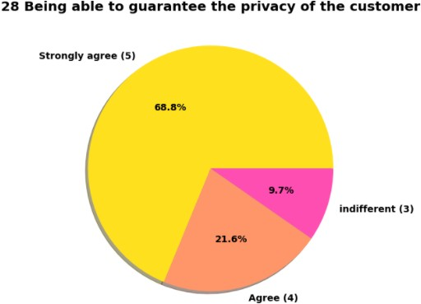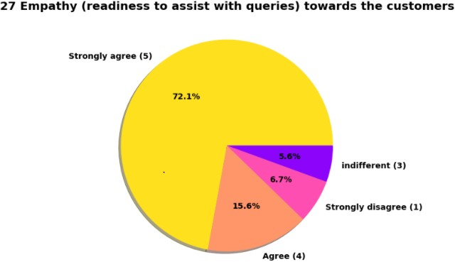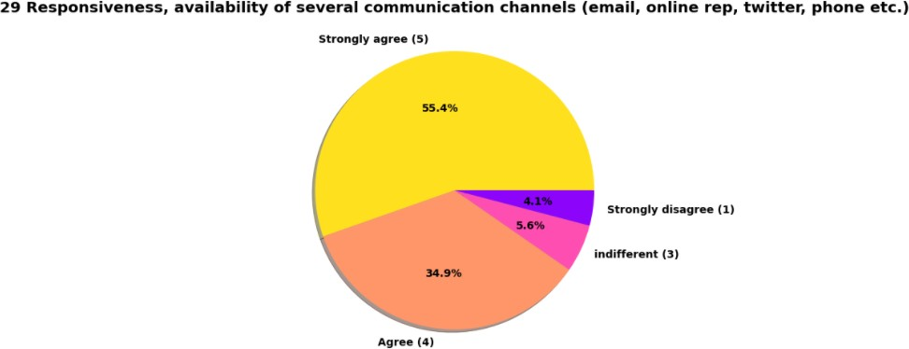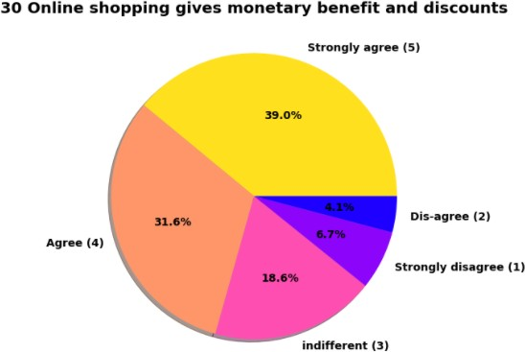

1. **Project Report on Data Analysis of Customer Retention in Ecommerce Sector**

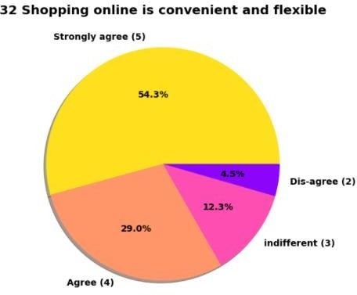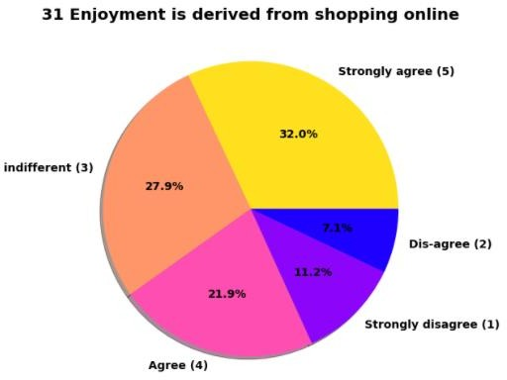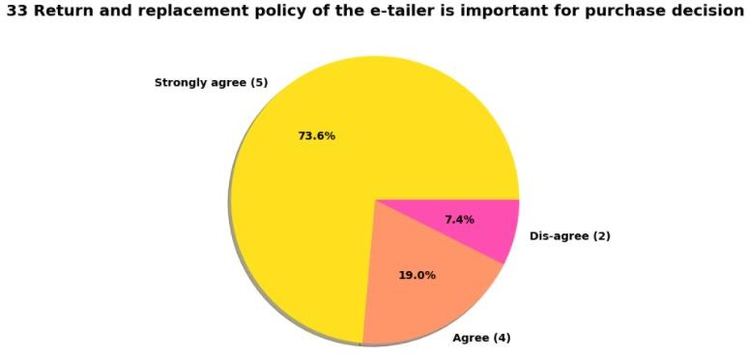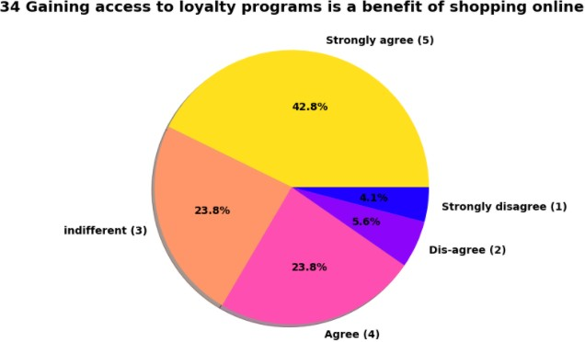

1. **Project Report on Data Analysis of Customer Retention in Ecommerce Sector**

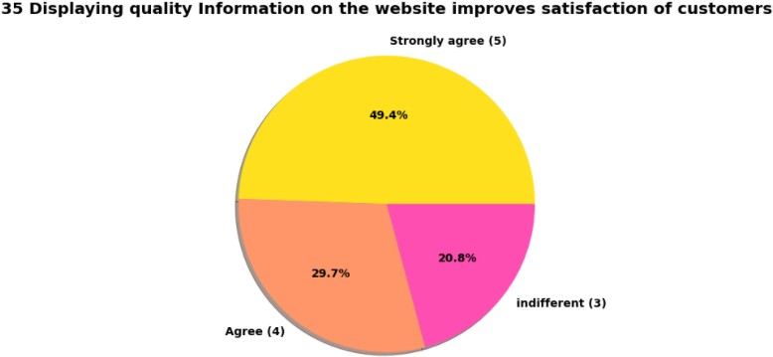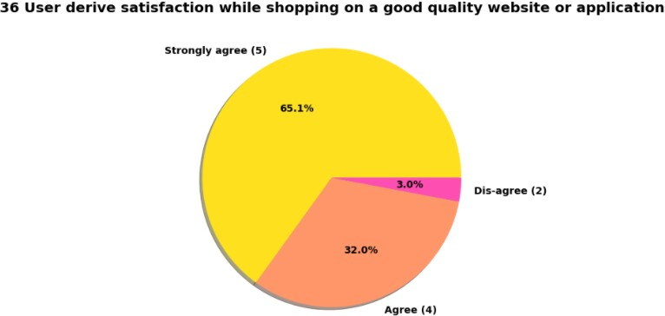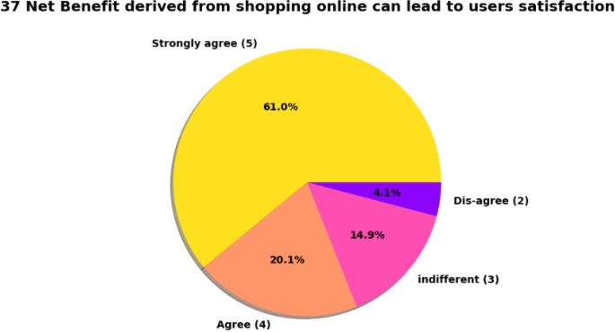

1. **Project Report on Data Analysis of Customer Retention in Ecommerce Sector**

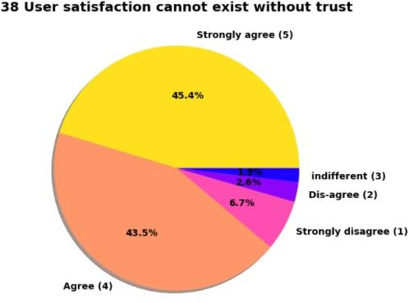

Observation:

* 72.1% Customer strongly agree thinks that company’s readiness to assist customer queries related to product is important factor in purchase decision.
* Pie plot also show that *being able to guarantee the privacy of the customer is important silent feature* for product selection.
* Another most important for product companies is availability of communication channels.
* Most of people enjoy physical shopping, we can see that for 32% customer enjoyment from online shopping strongly matter and for around 46% customer this online shopping enjoyment do not matter.
* Online shopping is 24/7 available with lot of varieties of product and with product return facility. This led to thinking among almost 85 % of customer thinks, online shopping is convenient & flexible than physical shopping.
* 73.6% customer thinks that return & replacement policy of e-seller is important factor for making purchase decision.
* 49.4% customer strongly agree and 29.7% customer agree that displaying quality information on website helps in decision making in turn improves customer satisfaction.

1. **Project Report on Data Analysis of Customer Retention in Ecommerce Sector**

* 45.4% of customer strongly agree over fact that *user satisfaction cannot exist without trust.*

### Exploring Feature Related to Customer Online Shopping Experiences

In this section we will analyse features related to Customer online shopping experiences like sense of adventure, monetary savings. Following features, we have analysed in this section:

* 1. 39 Offering a wide variety of listed product in several category
  2. 40 Provision of complete and relevant product information
  3. 41 Monetary savings
  4. 42 The Convenience of patronizing the online retailer
  5. 43 Shopping on the website gives you the sense of adventure
  6. 44 Shopping on your preferred e-tailer enhances your social status
  7. 45 You feel gratification shopping on your favourite e-tailer
  8. 46 Shopping on the website helps you fulfill certain roles
  9. 47 Getting value for money spent

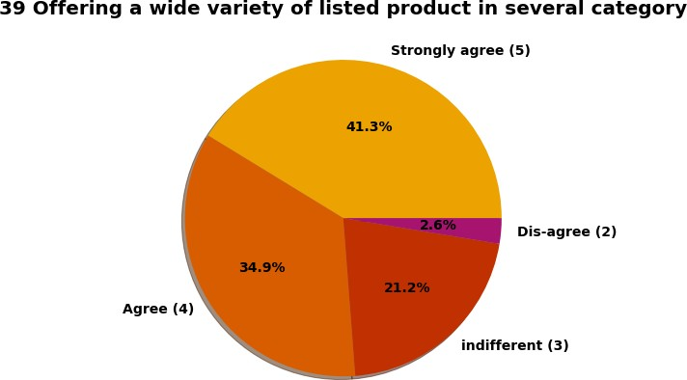

1. **Project Report on Data Analysis of Customer Retention in Ecommerce Sector**

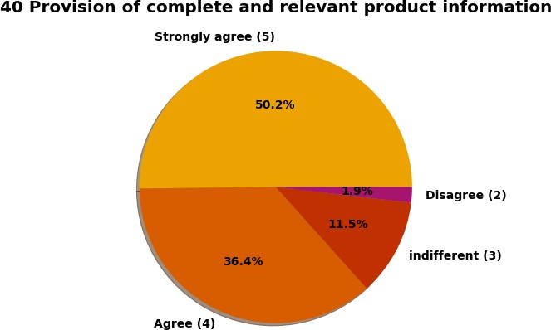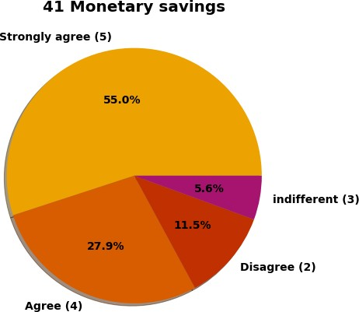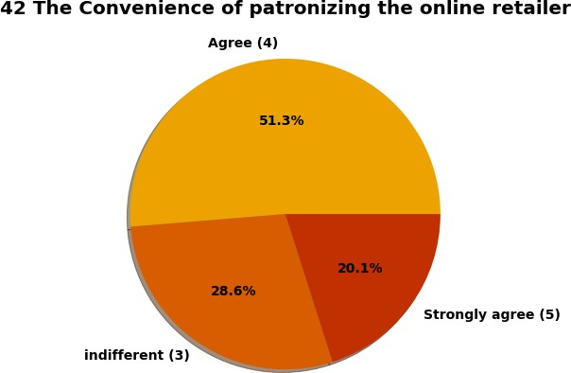

1. **Project Report on Data Analysis of Customer Retention in Ecommerce Sector**

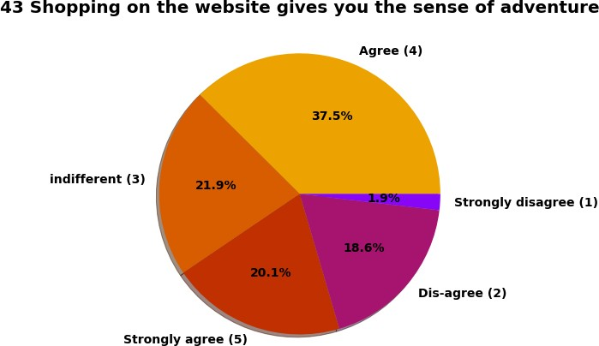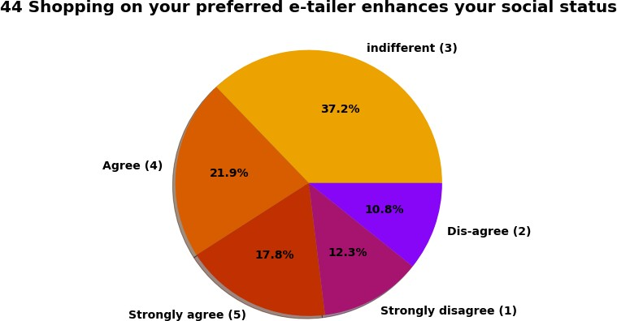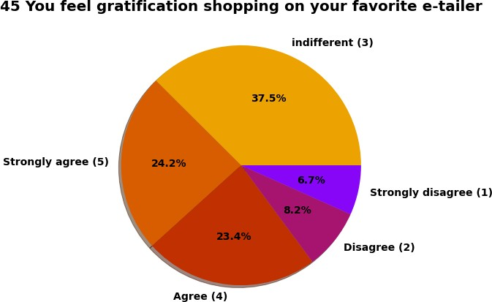

1. **Project Report on Data Analysis of Customer Retention in Ecommerce Sector**

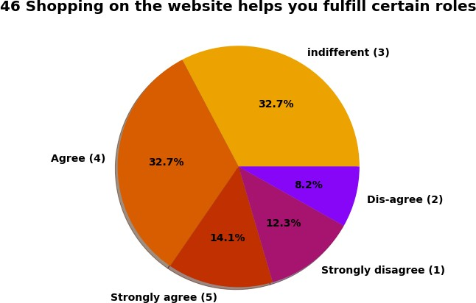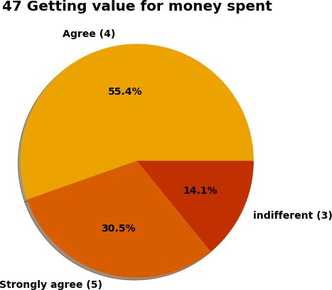

Observation:

* 50.2% Customer strongly agree & 36.4% customer agree that for good online shopping complete and relevant product information.
* Around 83% customer *pursue online shopping for Monetary Savings.*
* For 37.5 % customers Online shopping on website strongly gives the sense of adventure.

1. **Project Report on Data Analysis of Customer Retention in Ecommerce Sector**

#### We can see different peoples have different opinions about connection between e-tailer & social status. Same with gratification on favourite e-tailer.

* 55.4% people strongly agree and 30.5% people agree that they prefer online shopping because they get value of money spent.

### Exploring Opinion on Online Shopping Platform Websites by Customer

In this section we will analyse features related to website or application like performance, web layout. Following features, we have analysed in this section:

* 1. Easy to use website or application
  2. Visual appealing web-page layout
  3. Wild variety of product on offer
  4. Complete, relevant description information of products
  5. Fast loading website speed of website and application
  6. Reliability of the website or application
  7. Quickness to complete purchase
  8. Availability of several payment options
  9. Speedy order delivery
  10. Privacy of customers’ information
  11. Security of customer financial information
  12. Perceived Trustworthiness
  13. Presence of online assistance through multi-channel
  14. Longer time to get logged in (promotion, sales period)
  15. Longer time in displaying graphics and photos (promotion, sales period)
  16. Late declaration of price (promotion, sales period)
  17. Longer page loading time (promotion, sales period)
  18. Limited mode of payment on most products (promotion, sales period)
  19. Longer delivery period
  20. Change in website/Application design
  21. Frequent disruption when moving from one page to another
  22. Website is as efficient as before
  23. Which of the Indian online retailer would you recommend to a friend?

1. **Project Report on Data Analysis of Customer Retention in Ecommerce Sector**

On analysing above features following key finding: Observation:

* Majority, 64 customers agree that Amazon.in, Flipkart.com, Paytm.com, Myntra.com, Snapdeal.com are Easy to use website or application. *But overall if we look at count plot of easy-to-use application & website Amazon.in got individually 1st Rank*.
* 87 customers agree that Amazon.in, Flipkart.com have Visual appealing web-page layout than most of other market players.
* Around according to 125 people Amazon.in, Flipkart.com provides wide variety of offer on product.

#### We already know 50.2% Strongly agree over providing complete relevant product information, and here we can see that 100 customer think that Amazon.in, Flipkart.com provides complete information compare to others.

* Previously we know that 42.8 % customer strongly agree and 41.6

% customer agree over high loading & processing speed of website. Here we can see Majority of people think that *loading speed of Amazon.in is fastest while Flipkart.com slowest website to load*.

#### In terms of Reliability of website or application again Amazon top list.

* Majority of people also think that *Amazon.in tops the chart in terms of quickness purchase process* compare to others.
* Majority of customers think that *Amazon.in, Flipkart.com provides several payment options compare to others*.
* Safe & Speed delivery very much deciding factor in terms of purchase. In terms of *speed of delivery Amazon.in is much better than other online shopping platform* and *Flipkart.com worst among all* in terms of speed delivery of product.
* We already Know more than 90% Customer thinks that guarantee on privacy of their information is important for them. *Majority of customers trust Amazon.in more than other shopping platform for Privacy of customers’ information*
* Majority of customer trust Amazon.in followed by Flipkart.in over Security of their financial information. We also see very few peoples trust payment platform Paytm.

1. **Project Report on Data Analysis of Customer Retention in Ecommerce Sector**

* Amazon.in, Flipkart.com, Myntra.com, Snapdeal.com provide assistance through different multi-channel.
* Longer time to get logged in can annoyed customer. *Amazon.in take longer time to logged in while Flipkart.com take least time among all*.
* Majority of people agree that *Amazon.in, Flipkart.com* takes longer time in displaying and photos.
* Myntra.com followed by Paytm.com take longer page loading time.
* Most of people want *shorter delivery time frame*, majority customer agree that *Paytm.com takes longest time for delivery* compare to others.
* Amazon.in website is as efficient as earlier after upgradation.
* Majority 80 peoples recommended Amazon.in to their friends.

Based on analyse we have following recommendation for E-commerce companies

##### Amazon.com

Areas for further improvement:

* During promotions, try to give a disturbance free shopping experience to customers.
* Give more payment options to customers.
* Try to give price early during promotion.
* Reduce the delivery time of the products. Strong Area according to feedback by customer:
* Convenient to use and also a good website for shopping.
* Fast delivery of products.
* Availability of complete information of the products.
* Presence of online assistance through multi-channels.
* Reliable website or app, perceived trustworthiness.

##### Flipkart.com

Areas for further improvement:

* During promotions, try to give a disturbance free shopping experience to customers.

1. **Project Report on Data Analysis of Customer Retention in Ecommerce Sector**

* Give more payment options to customers.
* Try to give the price early during promotion.
* Reduce the delivery time of the products.
* Flipkart and Amazon almost share the same feedbacks with varying percentages as the only difference.

Strong Area according to feedback by customer:

* Convenient to use and also a good website for shopping.
* Fast delivery of products.
* Availability of complete information of the products.
* Presence of online assistance through multi-channels.
* Reliable website or app, perceived trustworthiness.
* Wild variety of products to offer.

##### Myntra.com

Areas for further improvement:

* + During promotions, try to give a disturbance free shopping experience to customers.
  + Try to give the price early during promotions.
  + Reduce the delivery time of the products during promotions. Strong Area according to feedback by customer:
  + Convenient to use and also a good website.
  + Availability of several payment options.
  + Faster products delivery.
  + Complete information of products available.
  + Reliable website or app, perceived trustworthiness.
  + Wild variety of product to offer

1. **Project Report on Data Analysis of Customer Retention in Ecommerce Sector**

##### Paytm.com

Areas for further improvement:

* + Reduce the delivery time of the products during promotions.
  + Try to give the price early during promotion.
  + During promotions, try to give a disturbance free shopping experience to customers.
  + Late declaration of price and discounts.
  + Frequent disturbance is occurring while moving from one page to another.

Strong Area according to feedback by customer:

* + Convenient to use and a good website.
  + Quickness to complete a purchase.
  + About 64% of the customers feel that either web or app is reliable.
  + Around 20% of the customers believe that Paytm has a wild variety of products on offer.

##### Snapdeal.com

Areas for further improvement:

* + Reduce the delivery time of the products during promotions.
  + Try to give the price early during promotion.
  + During promotions, try to give a disturbance free shopping experience to customers.
  + Late declaration of price and discounts.
  + No one has expressed to recommend Snapdeal to a contact as it has the most negative feedbacks among all other websites.

Strong Area according to feedback by customer:

* + Convenient to use.
  + 54% of the customers are happy about the availability of financial information security.

1. **Project Report on Data Analysis of Customer Retention in Ecommerce Sector**

# Chap 4. Conclusion

## Key Findings and Conclusions of the Study

* It is strong recommendation to companies that Do not spend more money over social media marketing & Display Adverts in their Digital Marketing campaign instead of that focus on Search engine Optimization & Email Marketing which will likely to be more effective to earlier.
* Complete description product on website or app is essential from making purchase decision.
* For both gender tendency of shopping is less for age greater than 51 years old.
* Most of them agrees that the functioning of app efficiently is also a major factor which helps in enhance user experience while doing online shopping.
* Around 50% customers abandon cart due to better alternative offer which is obvious reason. Another most common reason is promo code not applicable on particular product.
* Paytm and Snapdeal has poor customer services and there is lot of scope for further improvement.
* Amazon and Flipkart are standing best out in the market competent business strategies and lot advantages over there competitor.
* Mostly because, it is convenient and flexible, people prefer online shopping.
* people who have been shopping for more then 3-4 years are the ones who frequently shops.
* We can observe that most of the people, abandoned them cart as they were having better alternative offers
* To conclude, having the right customer retention strategy will keep sellers company growing if they know how to take advantage of it. Then customers will find their way back and continue buying stuff from the best company.

1. **Project Report on Data Analysis of Customer Retention in Ecommerce Sector**

## 2. Limitations of this work and Scope for Future Work

* This dataset has 269 rows which small. We can have more correct insight if more data is available.
* Machine Learning model can be built predict orientation of customer.
* Certain more feature around purchase details, price can able to much clearer picture which eventually help in advising solid recommendation.